CWWS Fund - Capital Improvement Projects
Project Name:  Maple Lane & River Crossing (12” Water Line) | Department:  Public Works - Utilities
Type of Project:  Capacity | Contact:  Chuck Soules
Total Project Cost:
$1,890,000

Description:
The project will install a new 12” water main under the Little Platte River for capacity and reliability. The waterline will go from Main Street to 3rd Street and will be approximately 2,560’ in length.

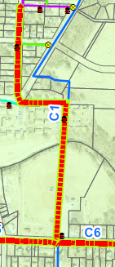
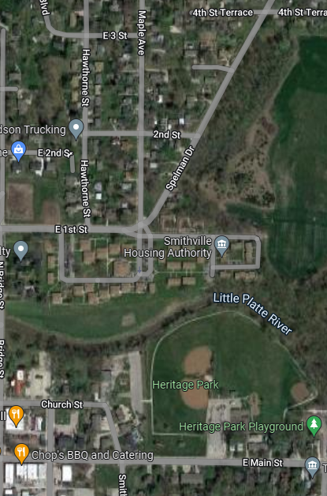
Justification:
This project is needed to ensure adequate water supply north of the Little Platte River. Currently, there is only one 8” main across the river and this improvement will provide additional capacity and reliability. This project was identified as a priority need in the Water Master Plan.

Planned Expenditures
 | FY2026 | Total
Construction | $1,890,000 | $1,890,000
Total | $1,890,000 | $1,890,000

Funding Sources
 | FY2026 | Total
CWWS Fund (Non-Impact Fees) | $1,190,000 | $1,190,000
CWWS Fund (Impact Fees) | $700,000 | $700,000
Total | $1,890,000 | $1,890,000

